Orange Group

Amanda Sherman - https://github.com/AmandaSherman/csd-310

Michael B. Streed - https://github.com/mbstreed19/csd-310

Karendaysu Wolfe - https://github.com/karendaysuwolfe/csd-310

Robin Pindel - https://github.com/rpindel/csd-310

12/11/2022

Module 11.1 Assignment

Bellevue University

Report #1

Employee time. Stan and Davis Bacchus decided to keep all existing personnel and staff when they inherited the winery. They also wanted to make sure the employees felt minimal change during the turnover. The employee time report can tell how long an employee worked on a certain day, they can keep monitor how many hours each employee is working. This will help them maintain consistent hours in scheduling their employees.

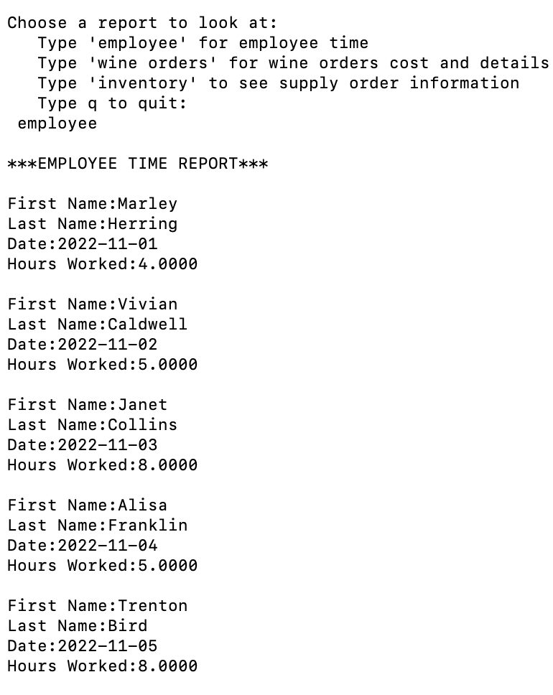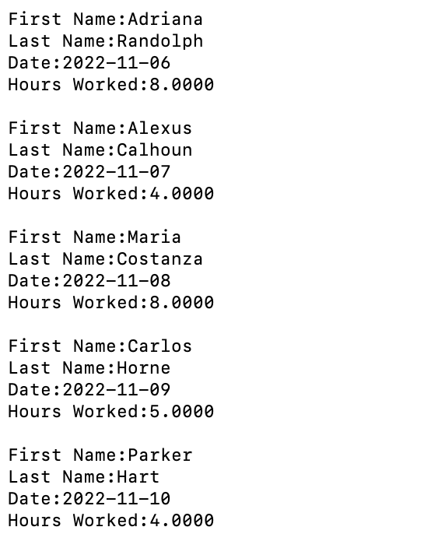

Report #2

Wine orders. Stan and Davis would like to know which wines are selling, as well as the inventory of the wine. This will tell them which wines are selling, exactly how much they are selling for, and quantity of wine on hand.

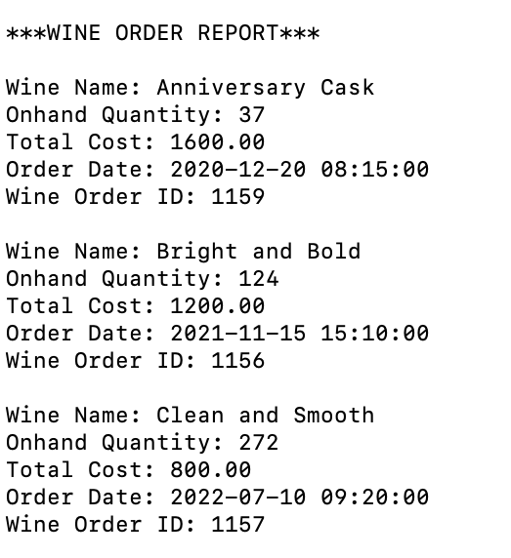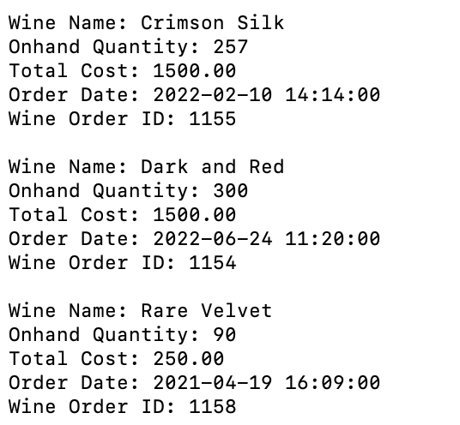

Report #3

Inventory. Stan and Davis would like an efficient way to monitor the supply orders, cost, and delivery. The inventory report shows each supply order, the supplier, total cost, date ordered, estimated delivery date, and actual delivery date.

